

**KABARAK UNIVERSITY**

**UNIVERSITY EXAMINATIONS**

**THIRD SEMESTER 2020/2021 ACADEMIC YEAR**

**EXAMINATION FOR THE DEGREE OF BACHELOR OF EDUCATION**

**PHYS 110 ELECTRICITY AND MAGNETISM 1**

**SPECIAL/SUPPLEMENTARY**

**STREAM:Y1S1 TIME: 2:00-4:00PM**

**EXAMINATION SESSION: SEP-DEC DATE : 15/9/2021**

**INSTRUCTIONS TO CANDIDATES**

1. **Answer Question 1 and any other two questions in the answer booklet provided.**
2. **Do not write on your question papers. All rough work should be done in your answer booklet.**
3. **Clearly indicate which question you are answering.**
4. **Write neatly and legibly.**
5. **Edit your work for language and grammar errors.**
6. **Follow all the instructions in the answer booklet**

**SECTION A: (COMPULSORY) TOTAL MARKS FOR THIS SECTION IS 30.**

**1.**

1. Defi ne magnetic flux and state its SI units . (2Marks)
2. State Kirchoff’s voltage and current laws (2Marks)
3. A capacitor from a 50V DC supply is discharged across a charge-measuring instrument and found to have carried a charge of 10μC. What was the capacitance of the capacitor and how much energy was stored in it? (5Marks)
4. Show that total flux density B is given by 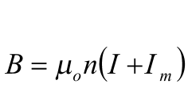 (5Marks)
5. A charge of 240C is moved when energy of 45J is applied between two points. Find the voltage between the two points. (4Marks)
6. An RL circuit with an inductor of inductance 16H and resistor of 10Ω is connected to the terminals of a battery of e.m.f. 12V and negligible internal resistance. Find
7. The initial rate of increase of current in the circuit (3Marks)
8. The current 0.75s after the circuit was switched on (4Marks)
10. State two similarities and two differences between electric force and magnetic force.

(4Marks)

1. State two characteristics of magnetic flux (2Marks)

**SECTION B. TOTAL MARKS FOR THIS SECTION IS 40.**

**ANSWER ANY TWO QUESTIONS FROM THIS SECTION. EACH QUESTION IN THIS SECTION CARRIES 20 MARKS.**

**2.**

1. i) What is meant by magnetic hysteresis? (2Marks)
2. Sketch a typical hysteresis curve and explain. (12Marks)

(b) What are the desirable magnetic properties for the material of (6Marks)

(i) the core of an electromagnet

(ii) a permanent magnet?

**3.**

a) i) Define capacitance. (2Marks)

ii) In the circuit below;

25V

C5

40uF

C4

20uF

C3

15uF

C2

13uF

C1

12uF

Calculate:

1. Total capacitance (5Marks)
2. Total charge (3Marks)
3. Charge on capacitor C3  (7Marks)
4. Voltage across the two capacitors in parallel (3Marks)

**4.**

a) What is magnetic flux? (1 Mark)

b) i)Consider a segment of conductor of length (L), cross sectional area (A), carrying current (I) placed in a uniform magnetic field (**B**), derive the expression of magnetic force  experienced by the wire segment. (8Marks)

ii) A straight horizontal segment of copper wire carries a current. What are the magnitude and direction of magnetic field needed to balance its weight? Given that it’s linear mass density is. (4Marks)

c) Consider an electron of charge being moved at a velocity of in a uniform magnetic field of at an angle of 30°.

1. Find the magnitude of magnetic force experienced by the proton (4Marks)
2. What will be the acceleration of the electron given that its mass is 

(3Marks)

**5.**

i) Consider the given resistor network circuit.

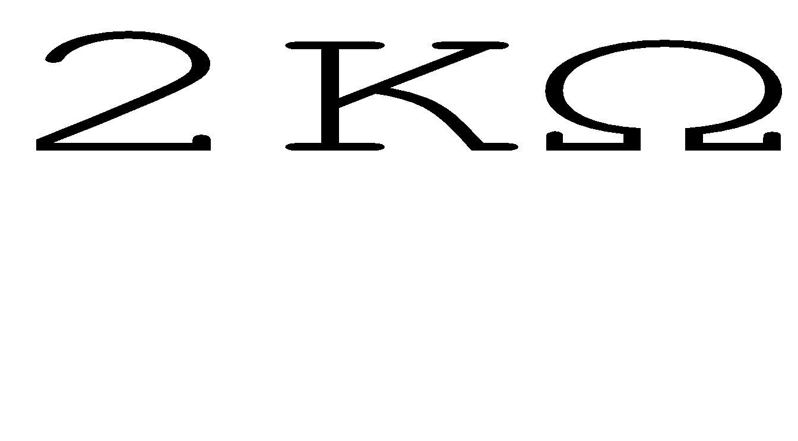

15V

R4

4KΩ

R1

5KΩ

R7

3KΩ

R3

2KΩ

R6

R5

4KΩ

R2

3KΩ

Calculate;

1. Total resistance (6Marks)
2. the total current in the circuit (3Marks)

b) When a battery of e.m.f. 12V is connected to a load resistor of resistance 15Ω, the terminal voltage measured is 10V. Find the internal resistance of the battery. (6Marks

c) Consider the given resistor circuit network

+

E2

30V

+

E1

45V

R2

24Ω

R3

8Ω

R1

48Ω

Calculate; Total resistance (5Marks)